**Objective:** Develop an python script to auto detect specified face inside a video and replace that detected face with custom image and generate fresh new video.

**Workflow Diagram:**

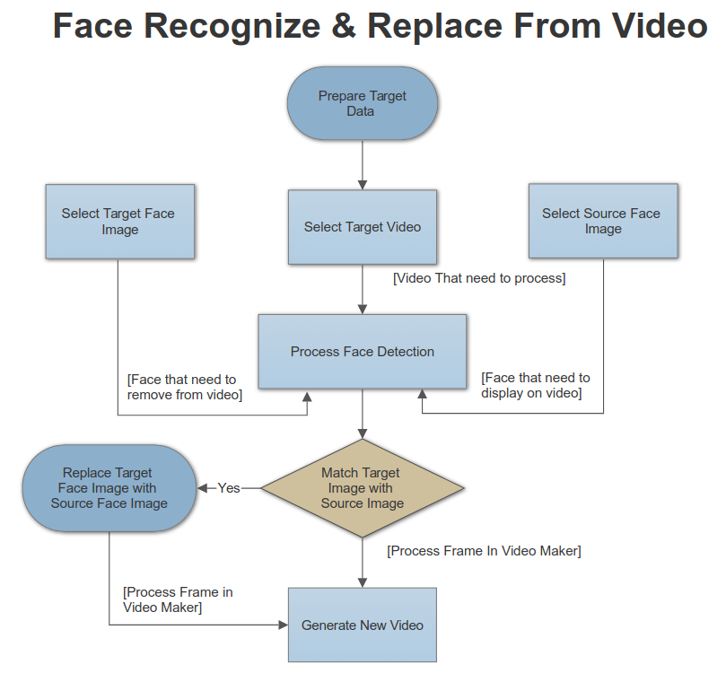

**Question:**

1. **Will the all detected faces will be replaced by source face image ? Or You will upload target face image and source face image as specified in Diagram ?**